**2.1 System Requirement**

**2.1.1 Hardware Requirements**

Processor : Pentium Series

Hard Disk Capacity : 20 GB

Ram : 512 MB

Keyboard & Mouse : Normal

Web camera : 2 mp (Mega Pixel)

**2.1.1 Software Requirements**

Operating System : Windows XP,7, 8, 10

Font End : PHP, HTML

Back End : JS, AJAX, MySQL

Browser : Microsoft Edge, Chrome, UC Browser

**2.2 Development Stage and Process**

**2.2.1 Problem Definition Stage**

This is very first stage to develop any project. It actually defines the aim the concept of the project. In this section, the purpose i.e. Why this particular required is explained.

**2.2.1.1 Use-Case Diagram**

**2.2.1.2 ER Diagram**

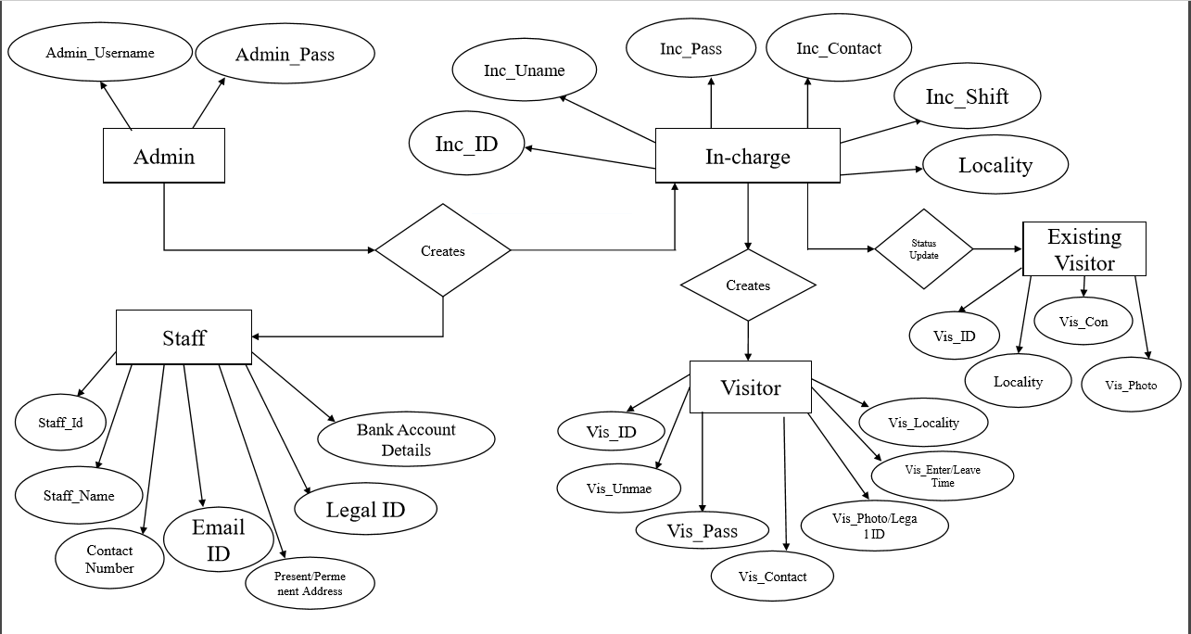

**2.2.1.4 Data Flow Diagram**